**Project 5 Part 2 Canny Edge Detection Complete**

Name: __Michael Fatemi___ Period: __7___ Date: ____3/19/2021_____

Is your lab name l052? (lowercase L followed by digits 052) ____Yes____

**Did you test your code on a school terminal using c++11?** ____Yes____

Does your main method call only part2()? ____Yes____

Did you create a gray image? _____Yes______

Did you apply the Sobell operator? _____Yes______

Did you apply a double threshold? _____Yes______

Did you apply non-max suppression? ______Yes_____

Paste here **4 clear pictures** of the initial picture, the image obtained after applying hysteresis, the image you obtained after applying non-maximum suppression, the image obtained after applying both:

Original



Hysteresis

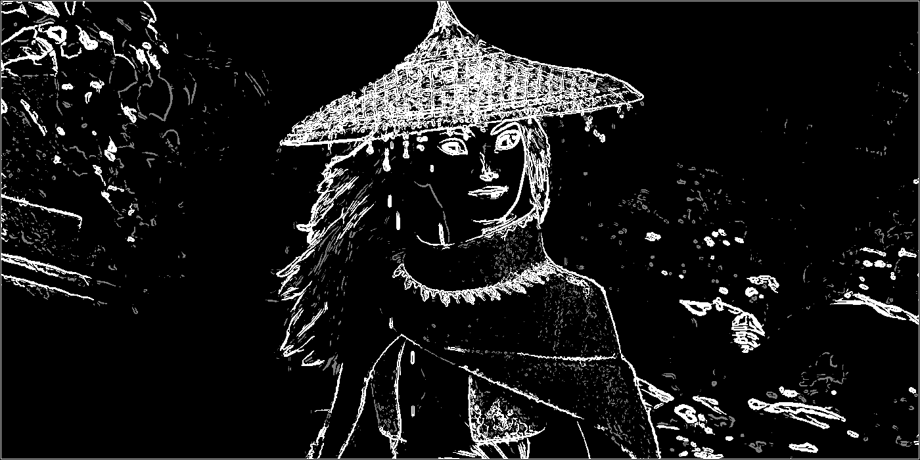

Non Max Suppression

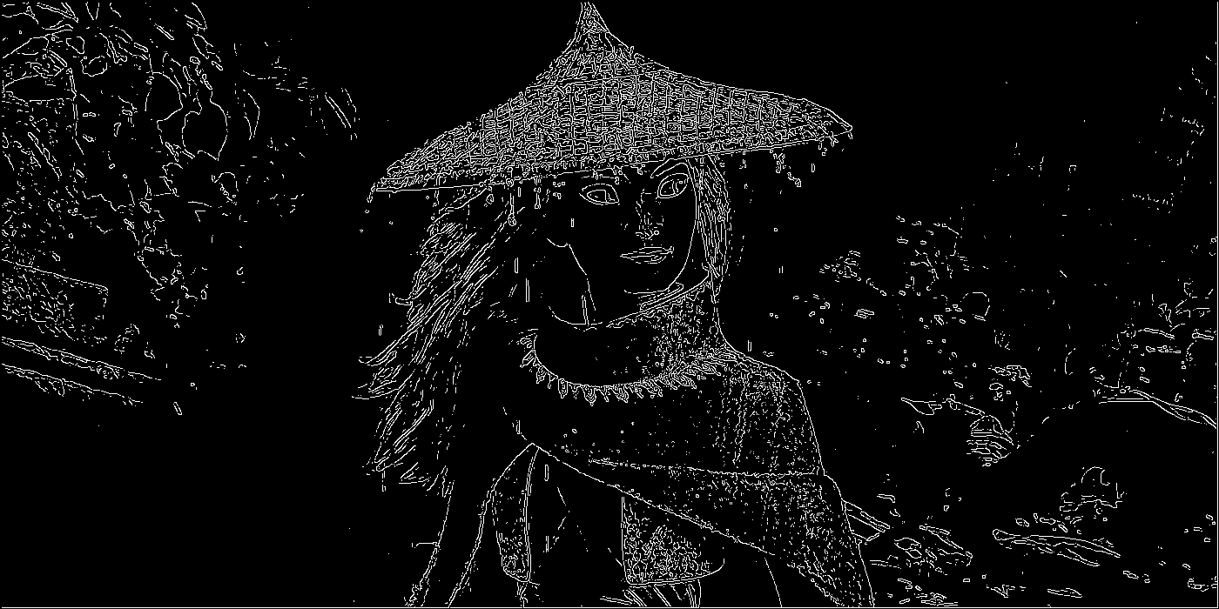

Combined

